RESULTS

A total of ________ from all four poultry farm locations in Edo state (Table 1).

Table 1: Lice collected from four poultry farms in Edo state, Nigera.

|  |  |  |  |
| --- | --- | --- | --- |
| Poultry farm location | *Mecanthis Straminus* | *Menopon galinae* | Total |
| Eluseh | 120 | 15 | 135 |
| Iguosa | 142 | 0 | 142 |
| Okhoro | 145 | 7 | 152 |
| SSQ | 156 | 19 | 175 |

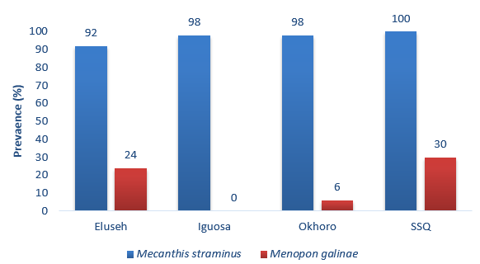

Figure 1: Prevalence (%) of lice infestation on sampled poultry birds from farms in Edo state, Nigeria.

Table 2: mean abundance of lice species in the four poultry farms in Edo state, Nigeria.

|  |  |  |  |  |
| --- | --- | --- | --- | --- |
| Lice species | Location (Mean+ SE) | | | |
| Eluseh | Iguosa | Okhoro | SSQ |
| *M. Straminus* | 2.40+0.16a | 2.84+0.16ab | 2.90+0.18ab | 3.12+0.14b |
| *Me. galinae* | 0.30+0.09a | 0.00+0.00a | 0.14+0.09a | 0.38+0.09a |

*The results are from the quasipoisson distribution and multiple comparisons by Tukey post hoc. Different letters indicate a significant difference (P<0.05) when compared within lice species.